**Talend Screenshots**

* **Dimensions**

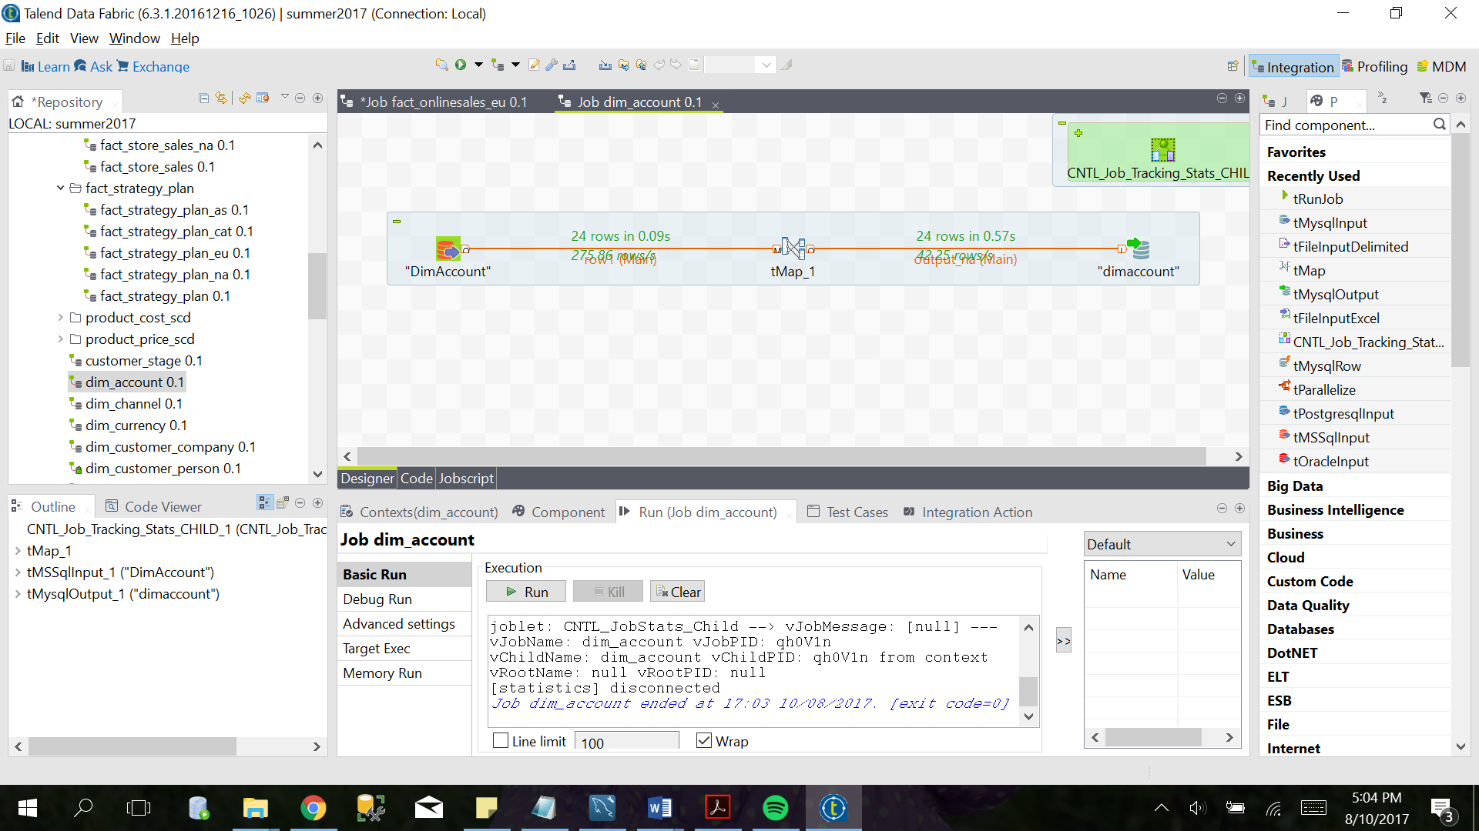

Figure 1: dimAccount

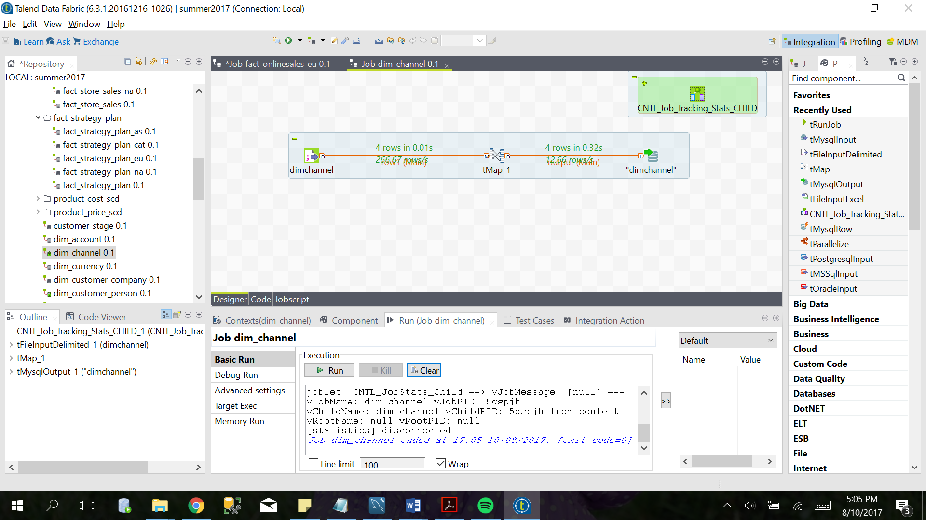

Figure 2: dimChannel

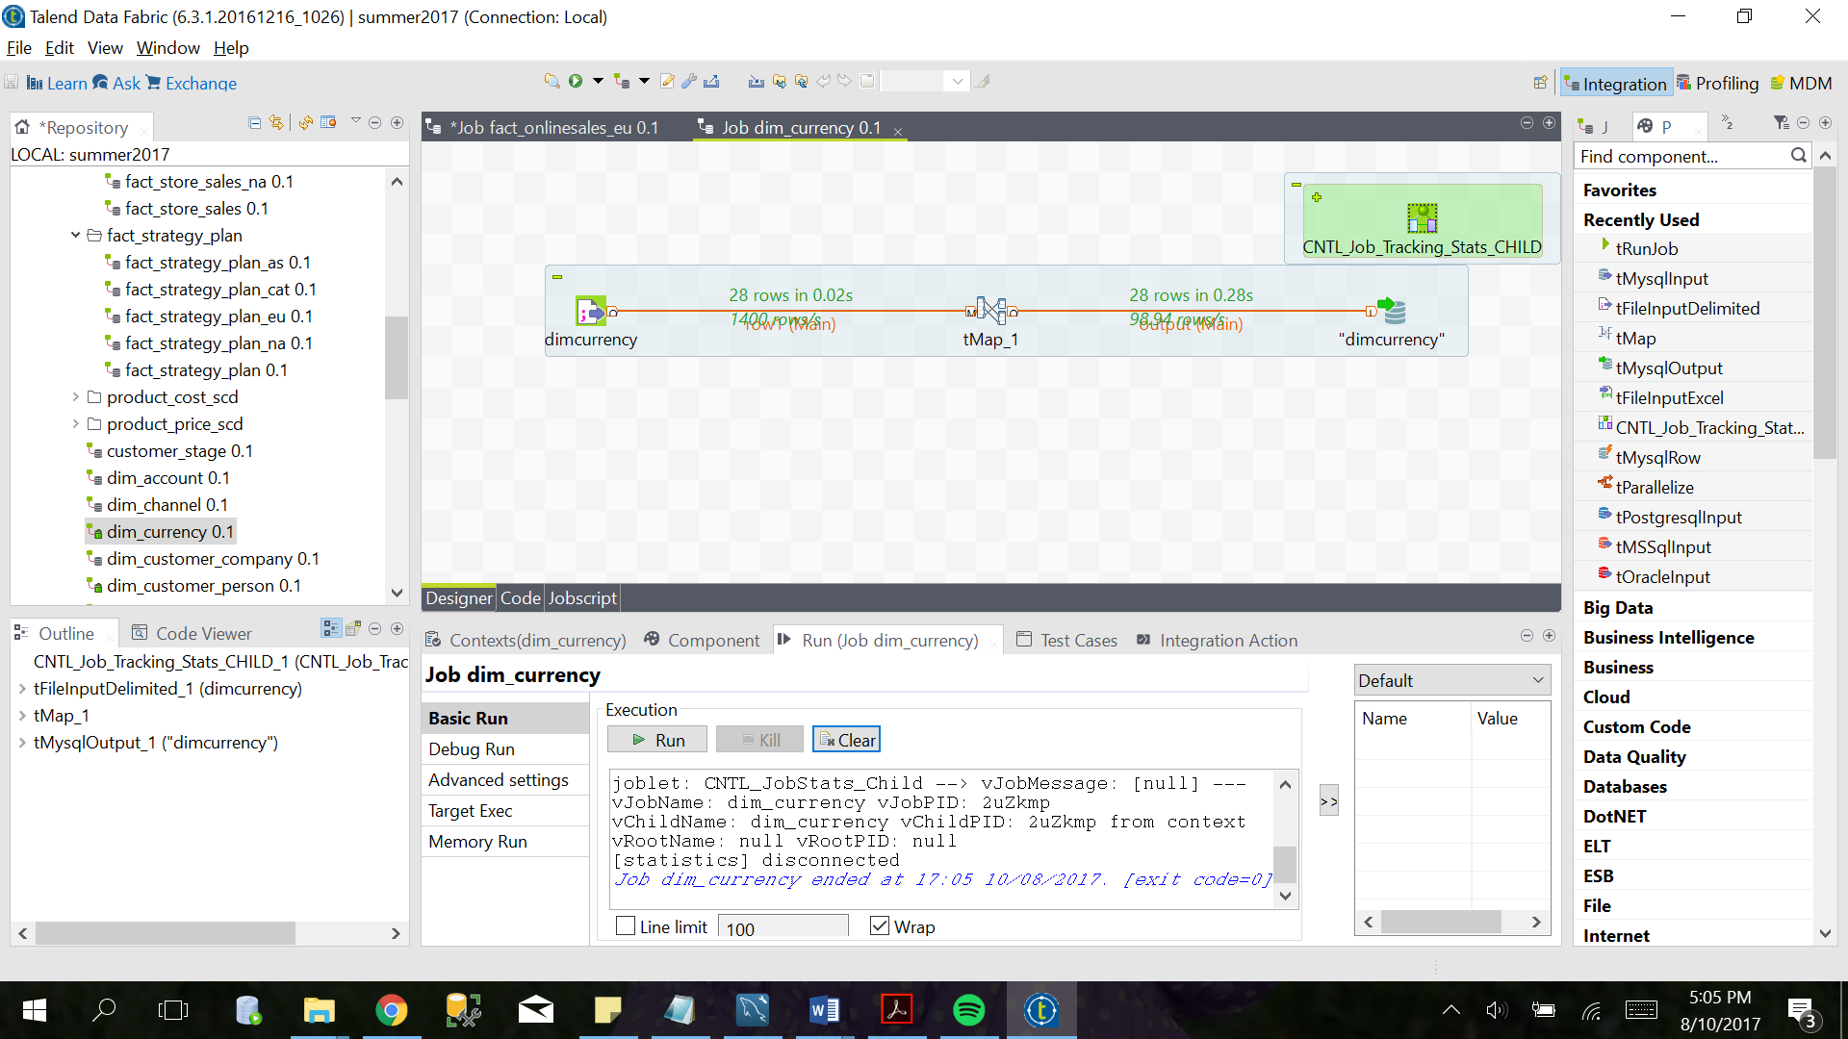

Figure 3: dimCurrency

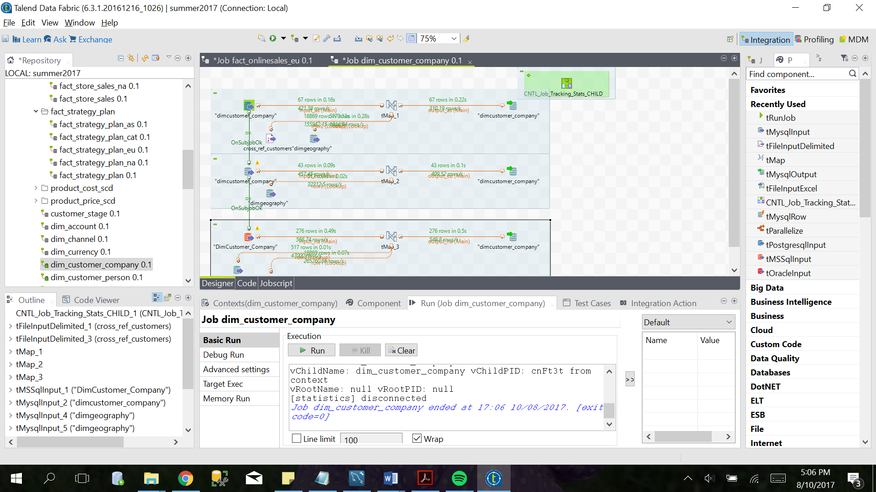

Figure 4: dimCustomerCompany

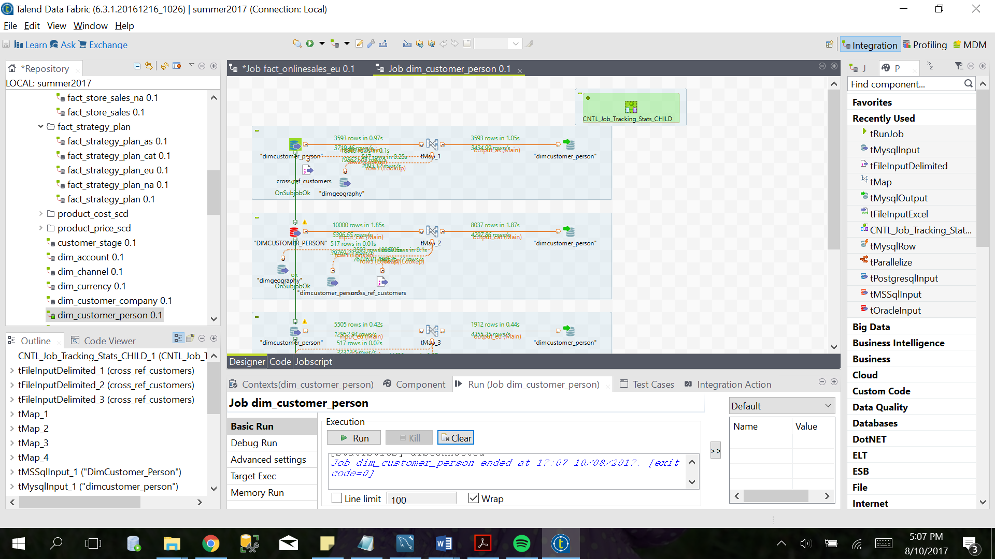

Figure 5: dimCustomerPerson

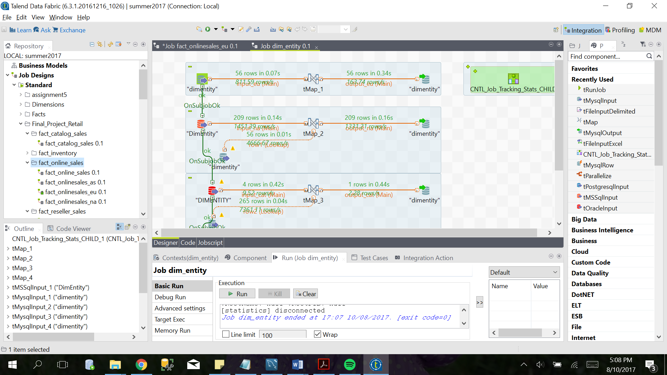

Figure 6: dimEntity

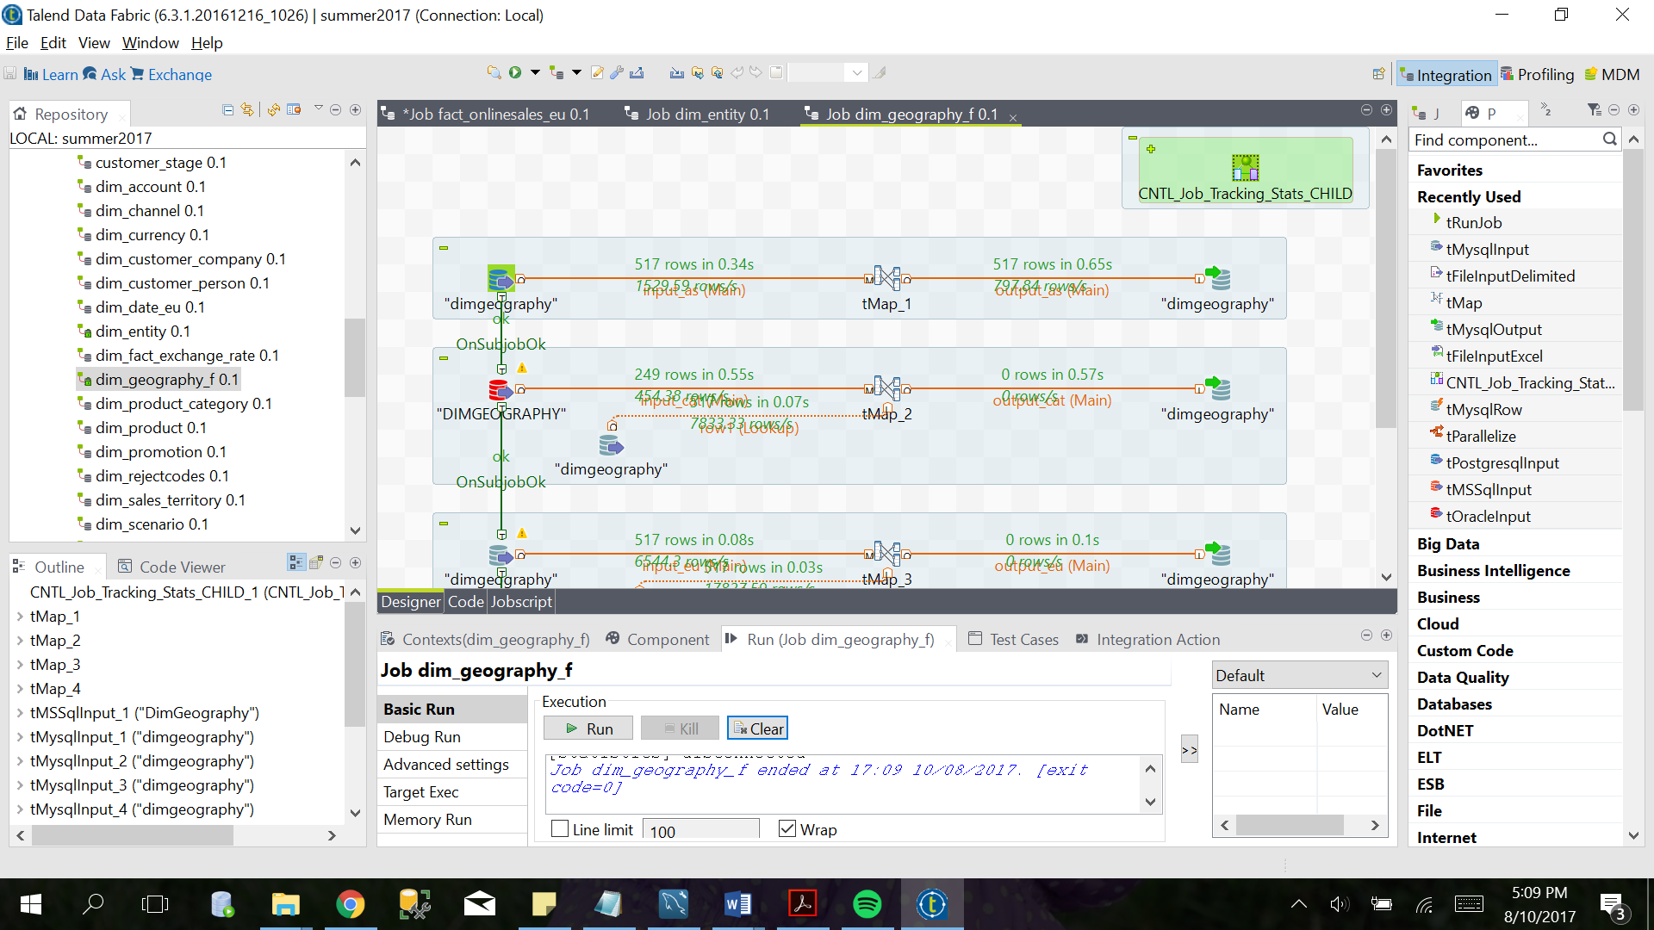

Figure 7: dimGeography

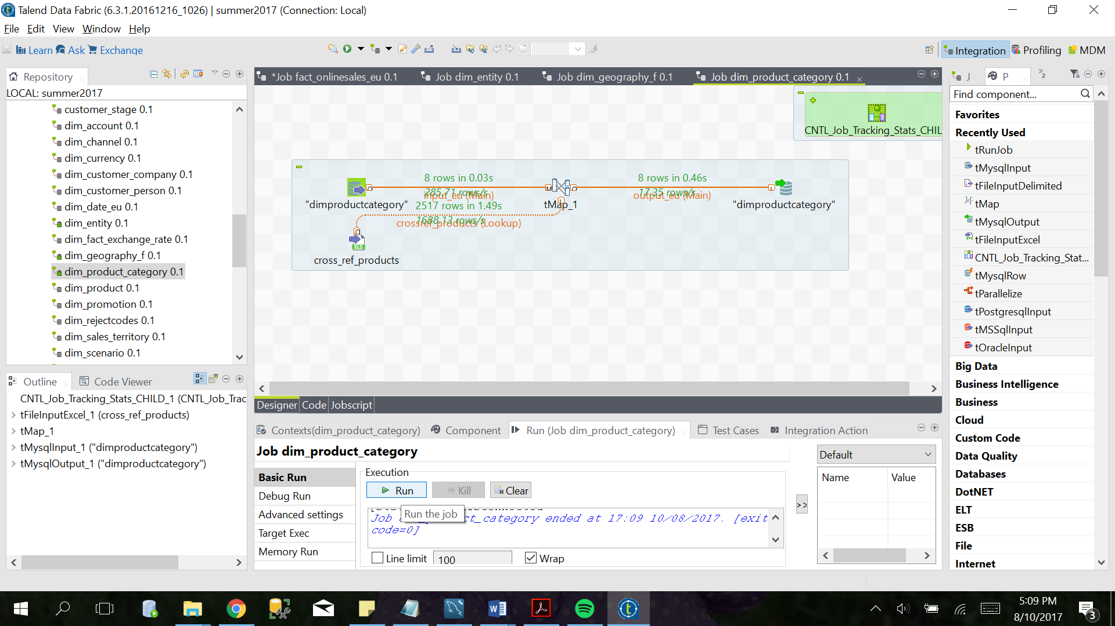

Figure 8: dimProductCategory

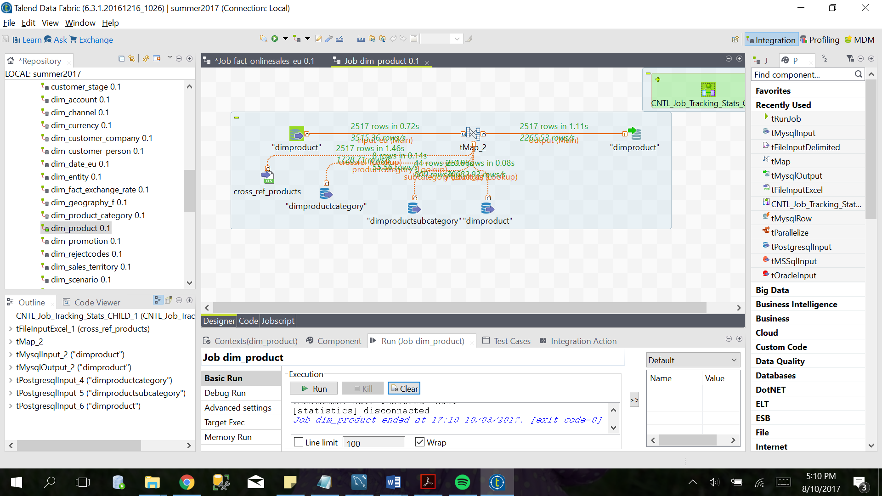

Figure 9: dimProduct

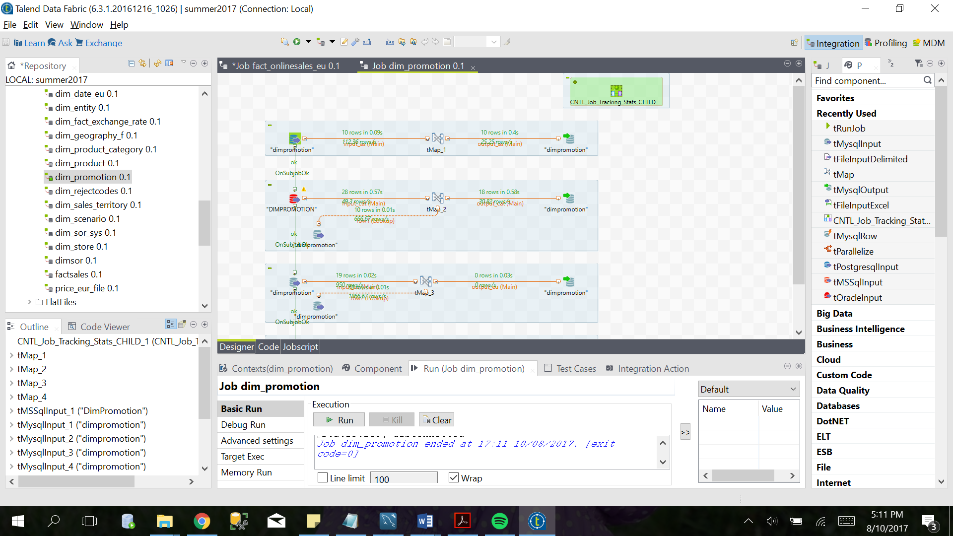

Figure 10: dimPromotion

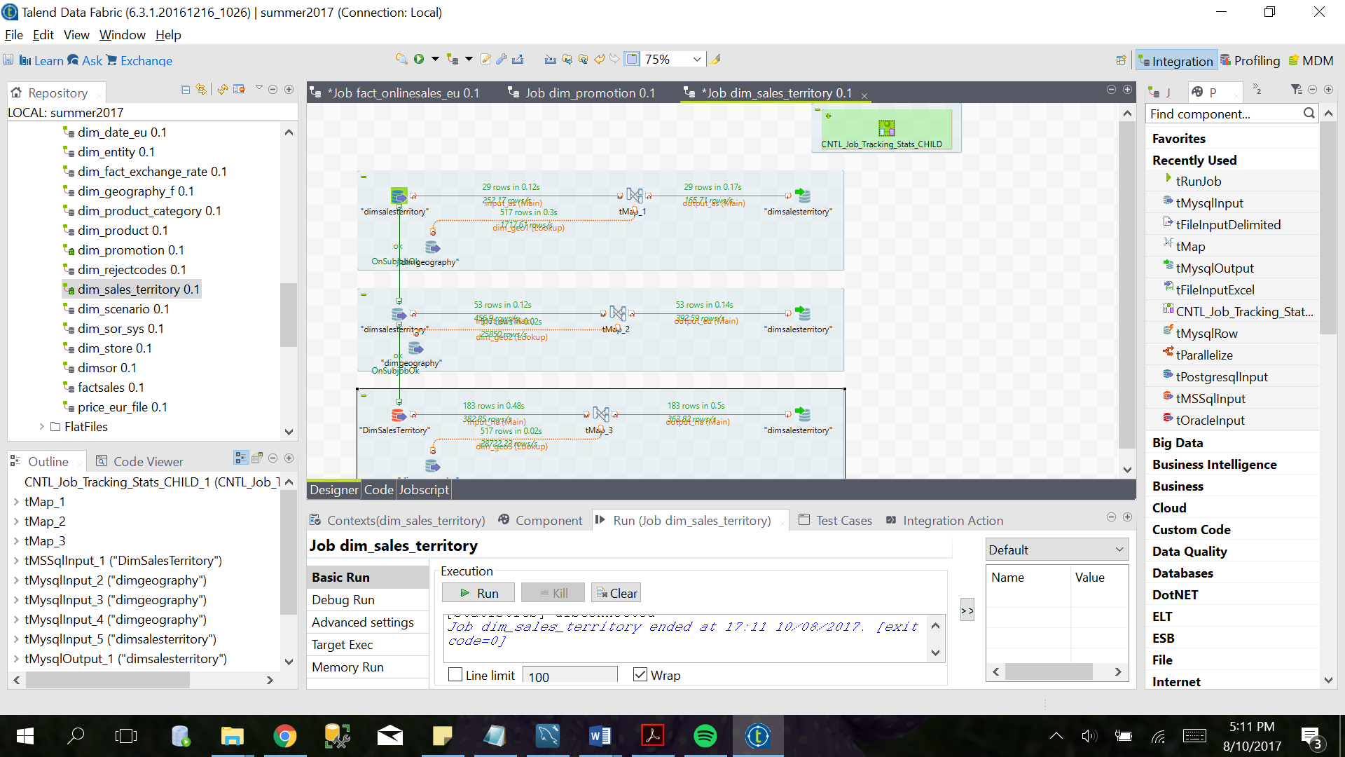

Figure 11: dimSalesTerritory

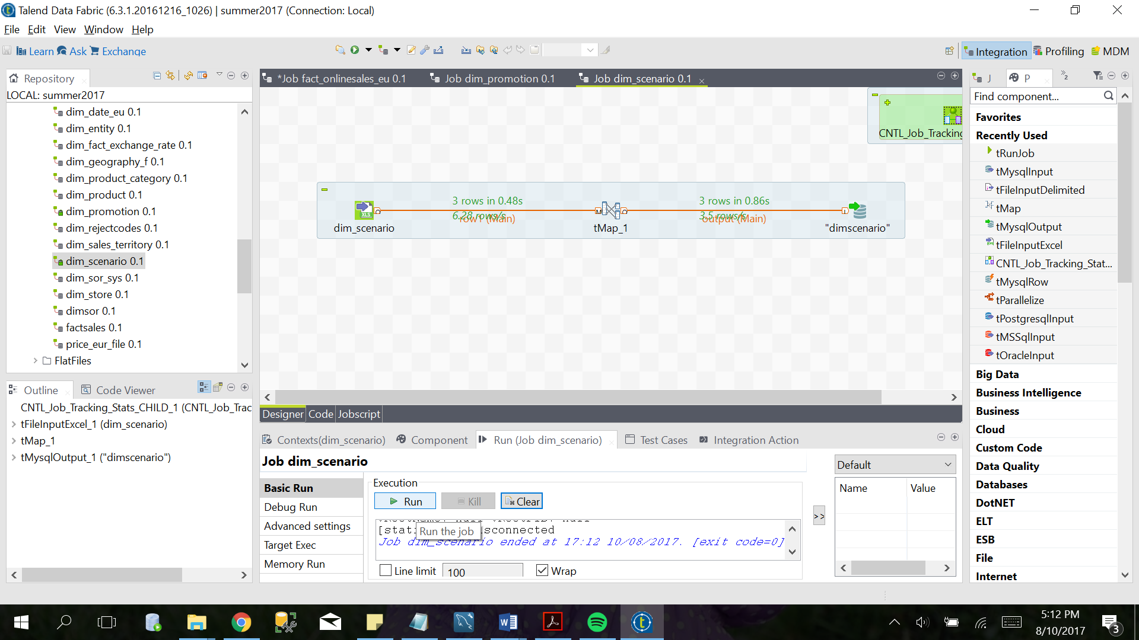

Figure 12: dimScenario

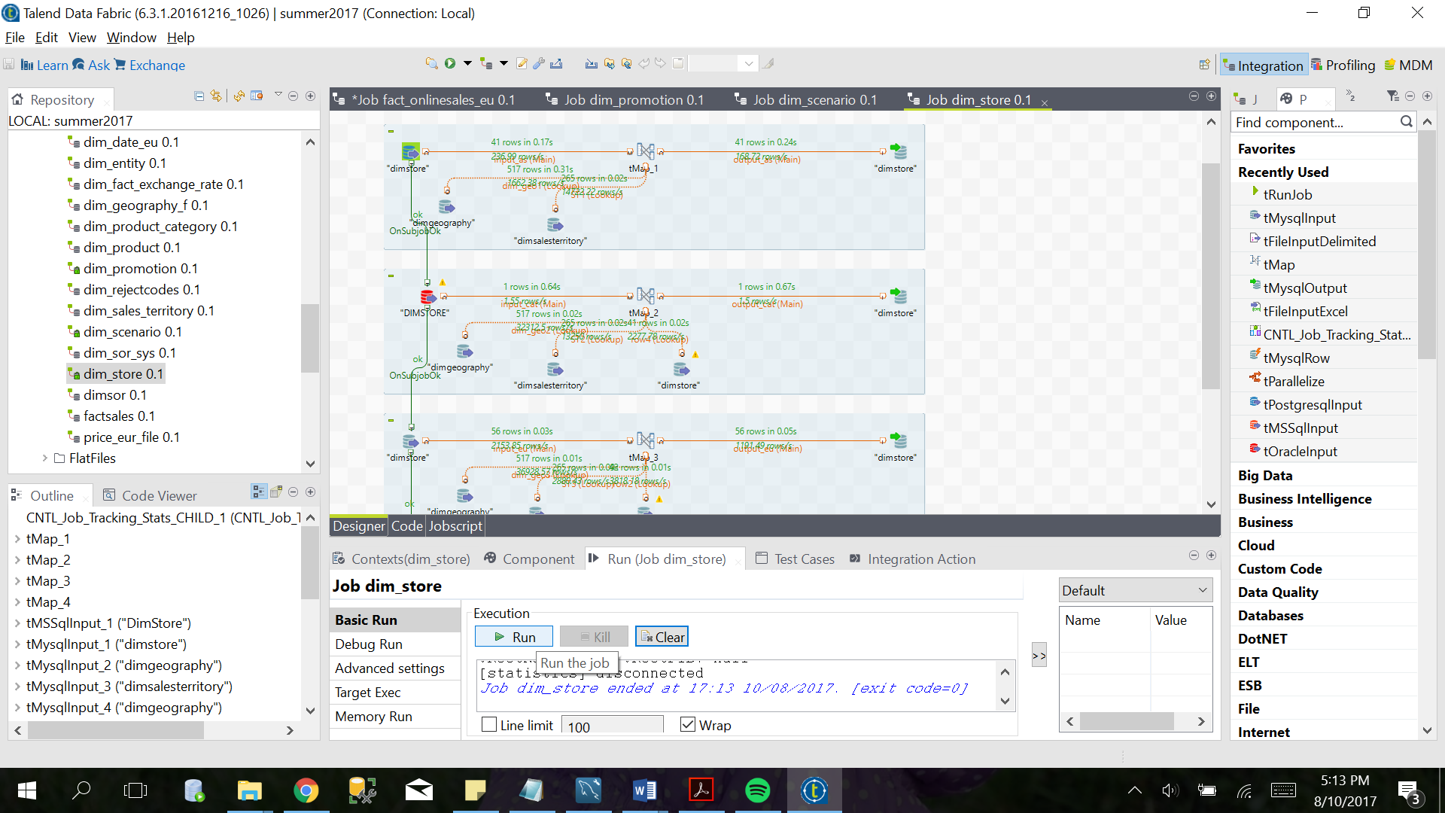

Figure 13: dimStore

* **Facts**

Fact Strategy Plan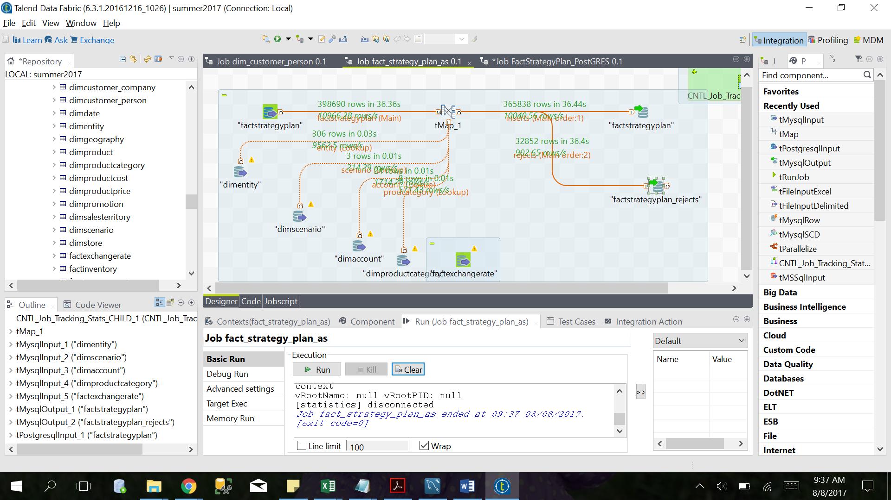

Figure 14: factStrategyPlan_as

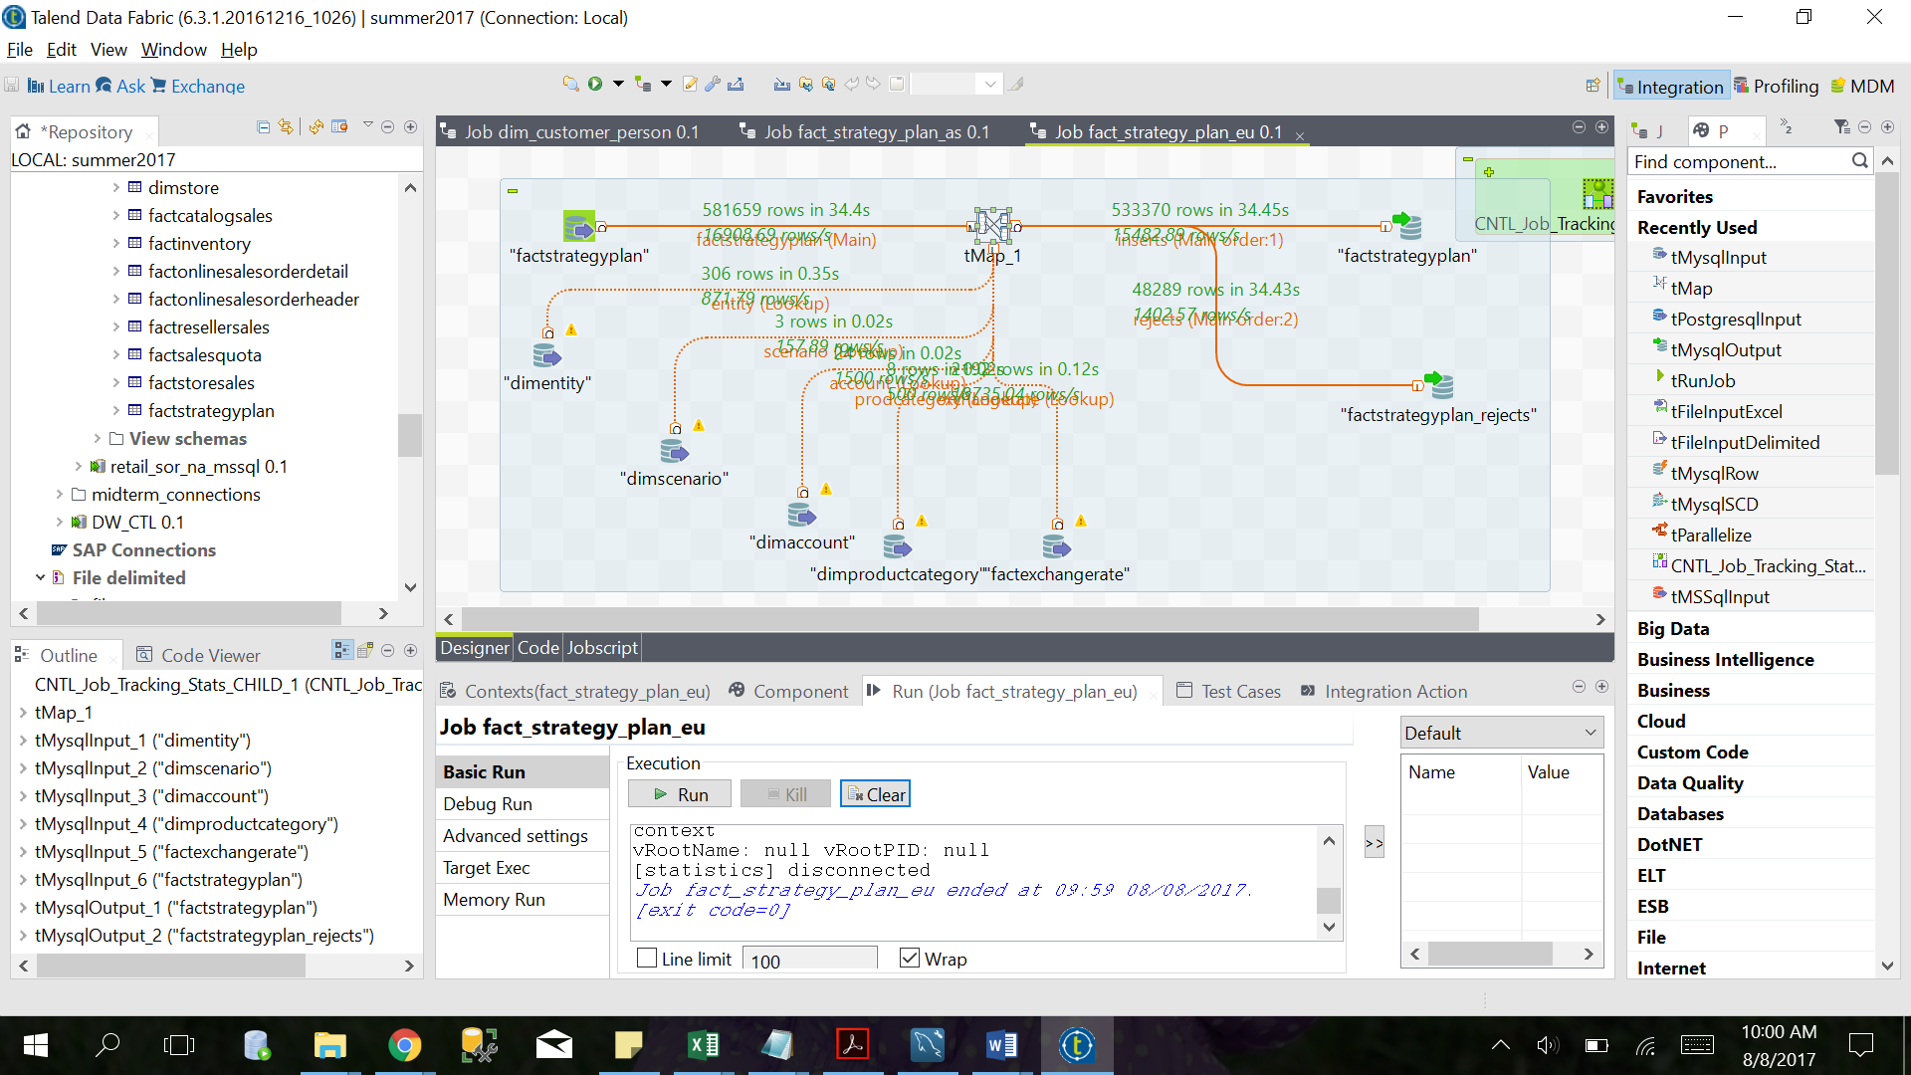

Figure 15: factStrategyPlan_eu

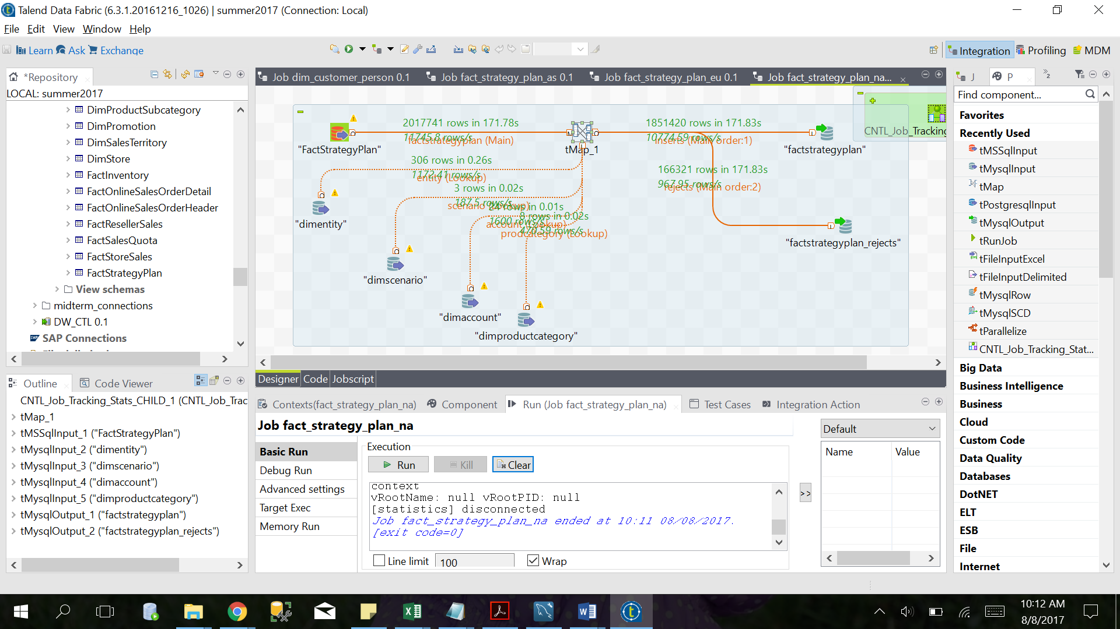

Figure 16: factStrategyPlan_na

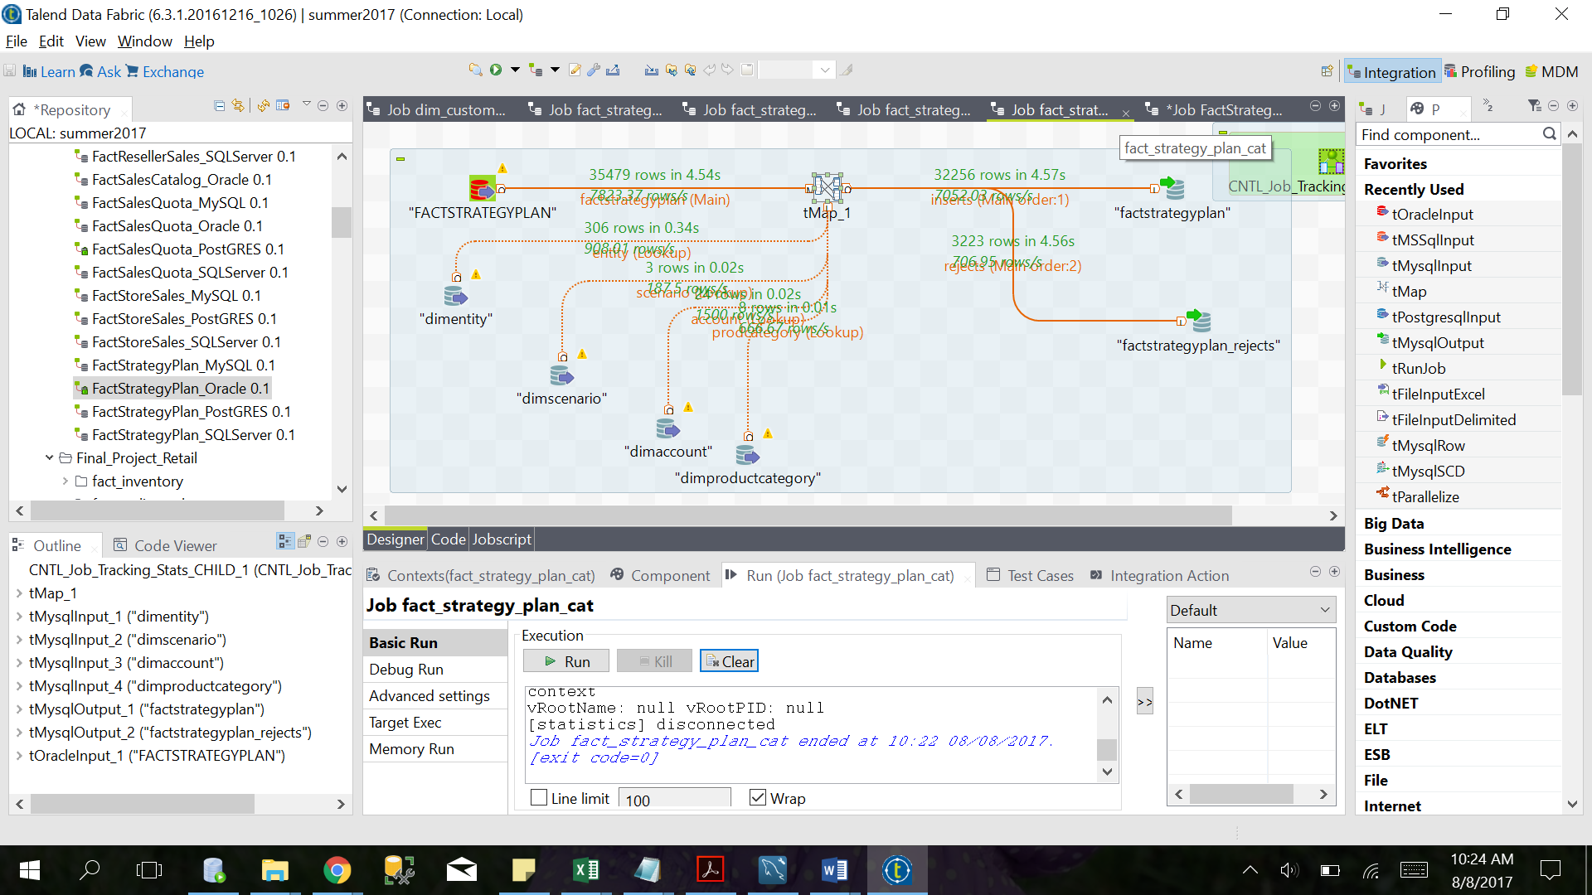

Figure 17: factStrategyPlan_cat

Fact Catalog Sales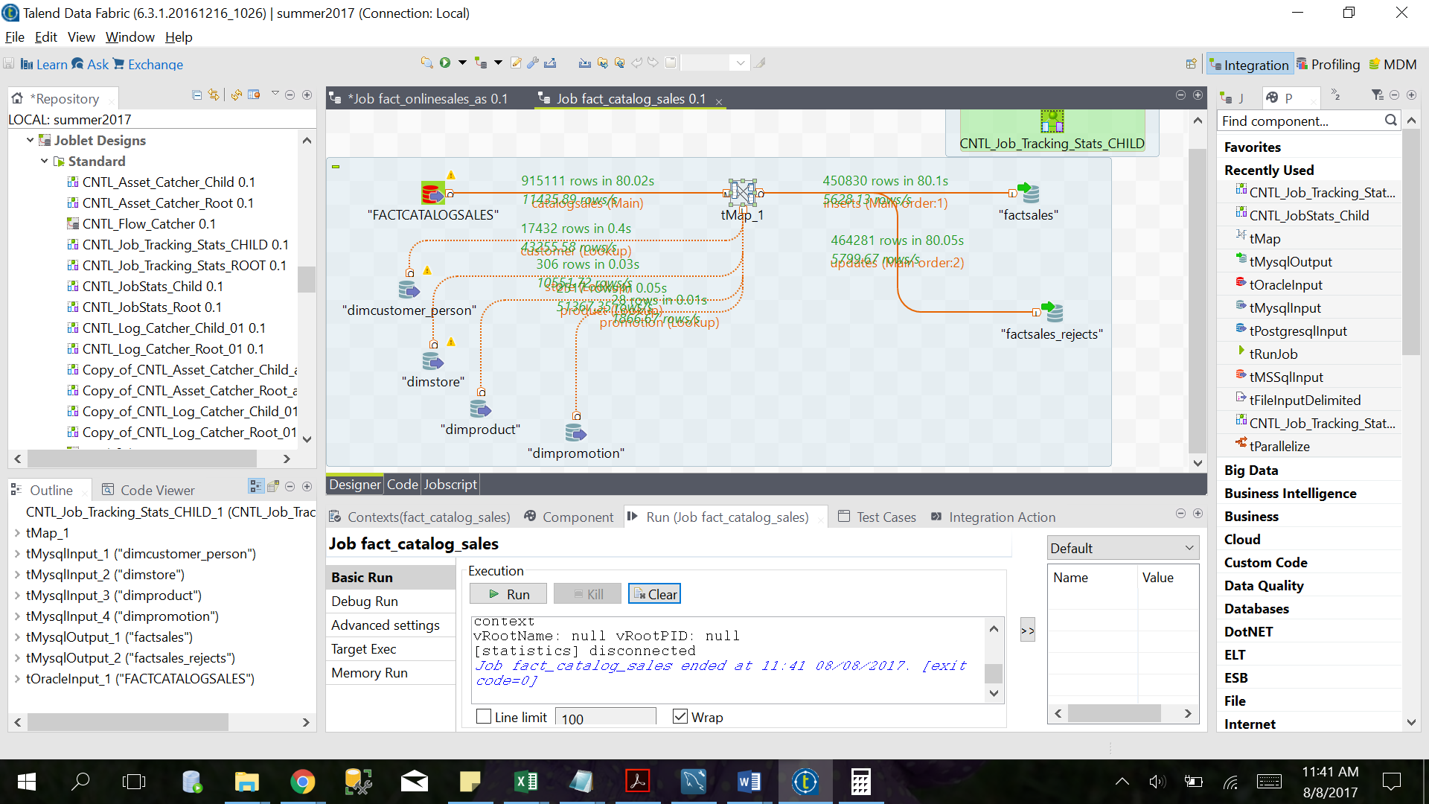

Figure 18: factCatalogSales

Fact Reseller Sales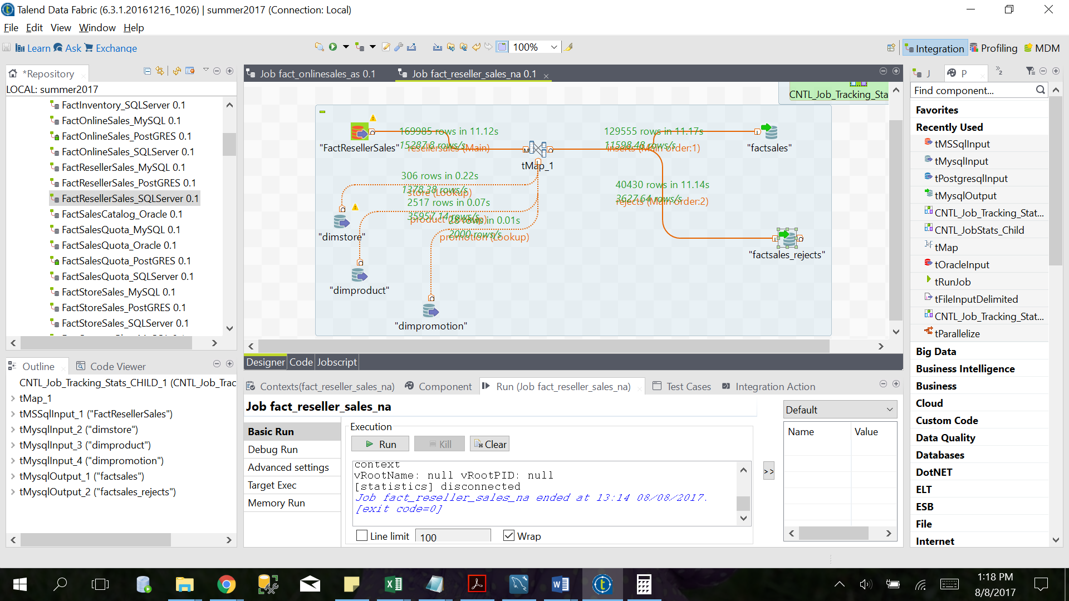

Figure 19: factResellerSales

Fact Store Sales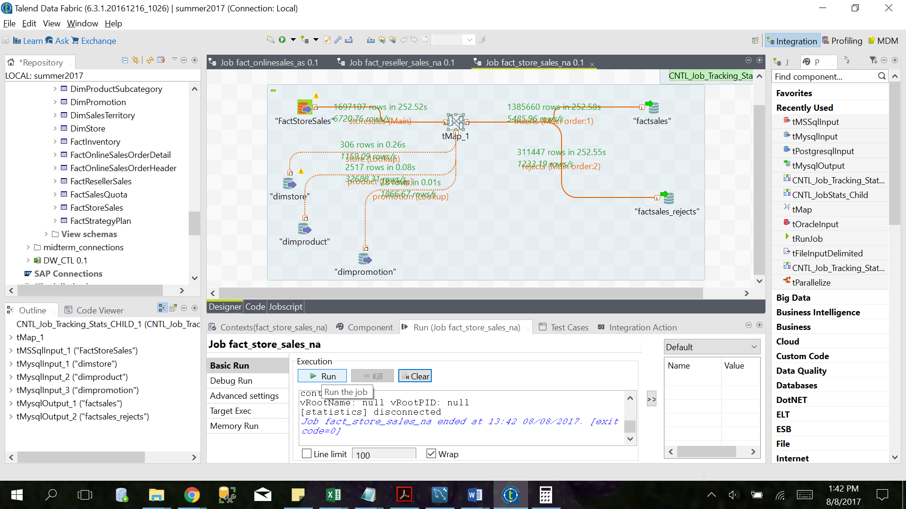

Figure 20: factStoreSales_na

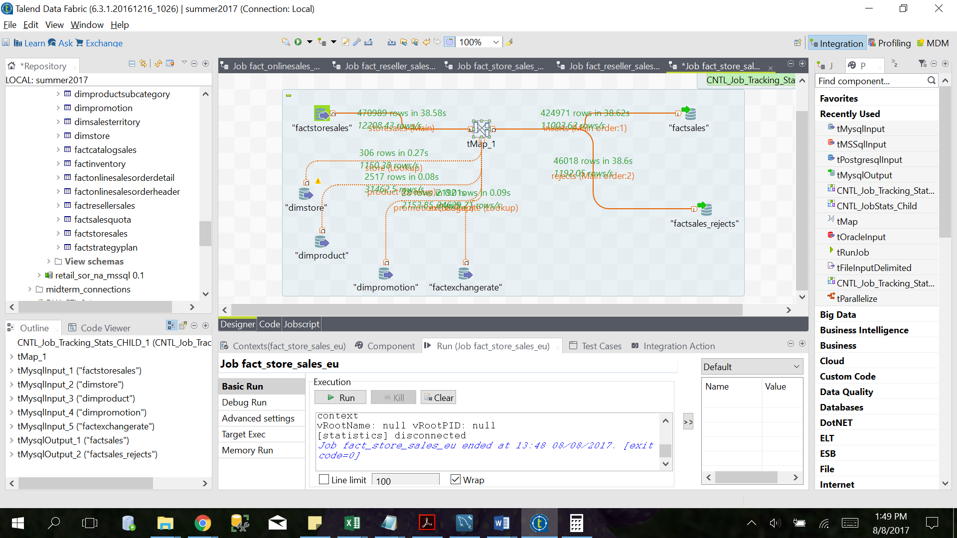

Figure 21: factStoreSales_eu

Fact Sales Quota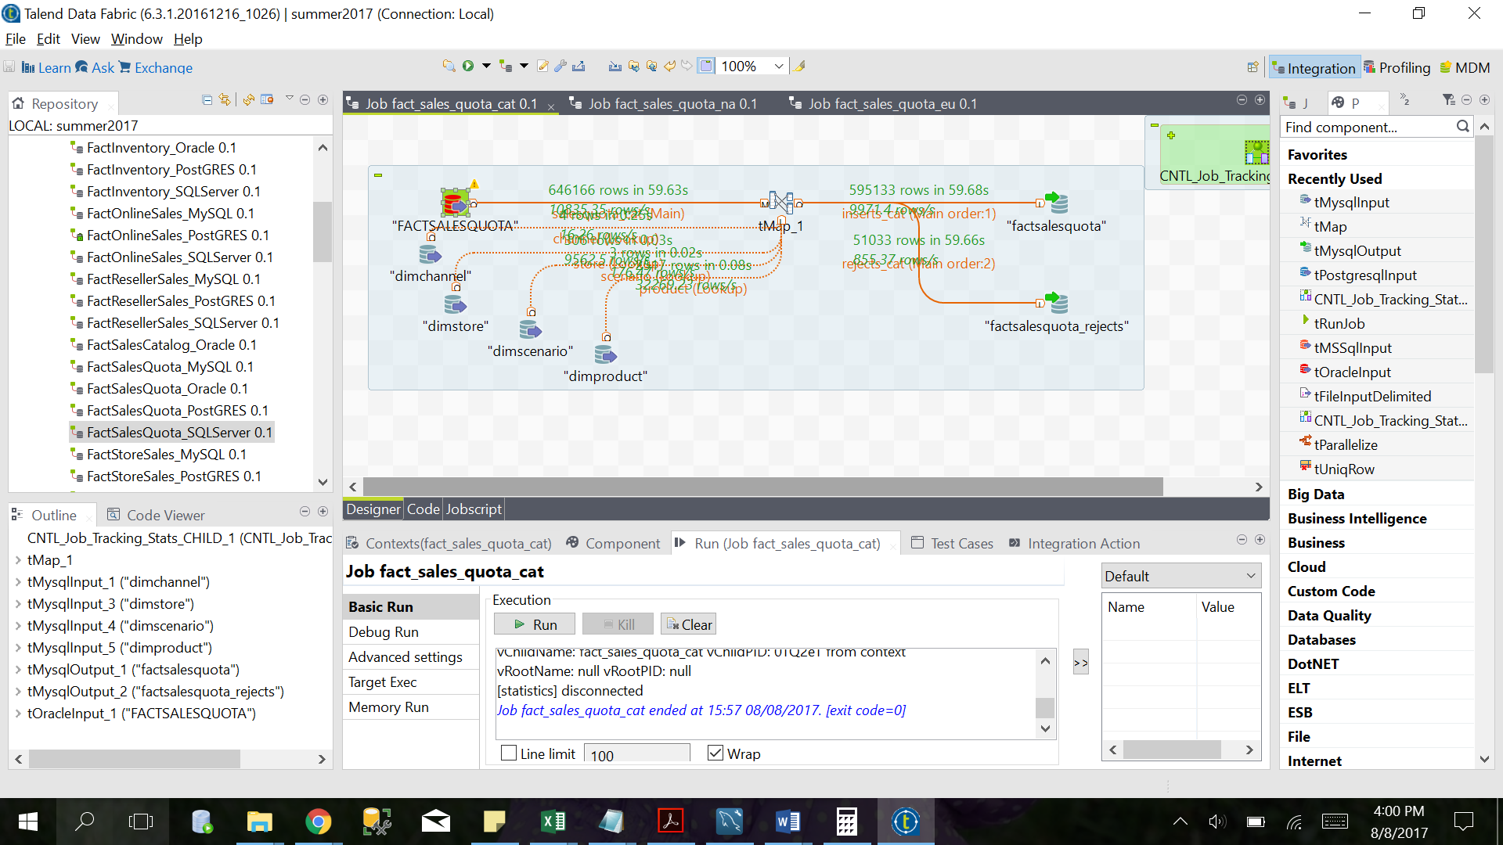

Figure 22: factSalesQuota_cat

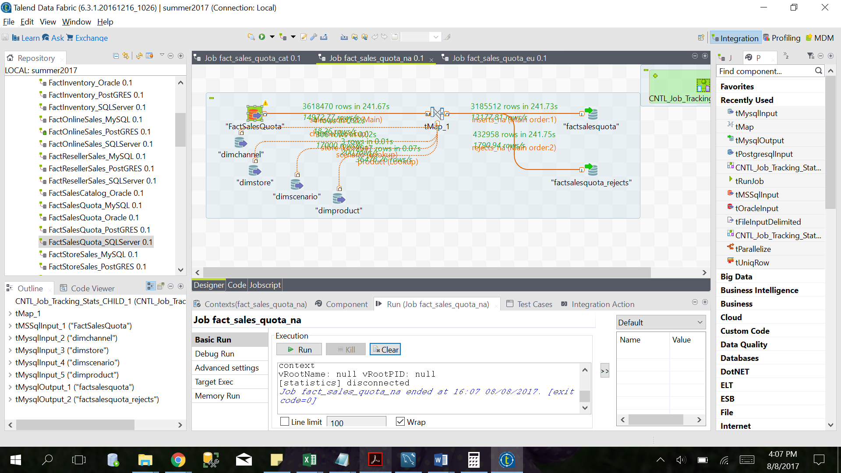

Figure 23: factSalesQuota_na

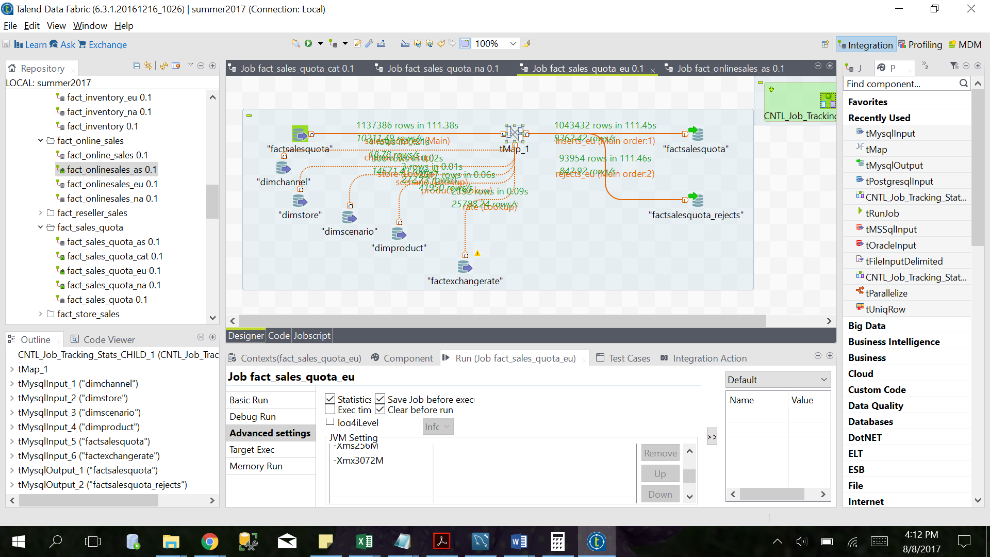

Figure 24: factSalesQuota_eu

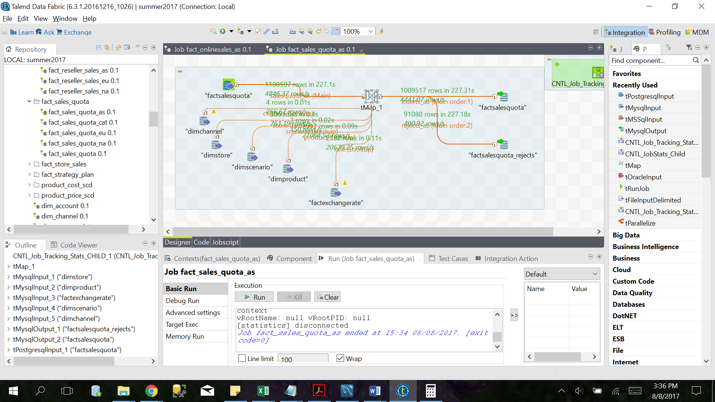

Figure 25: factSalesQuota_na

Fact Online Sales

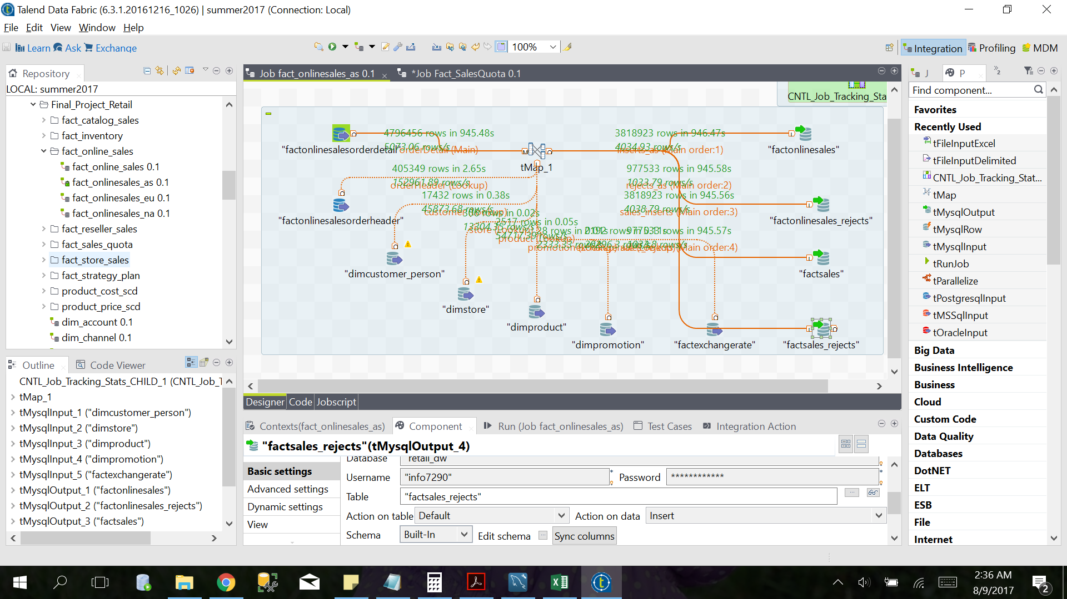

Figure 26: factOnlineSales

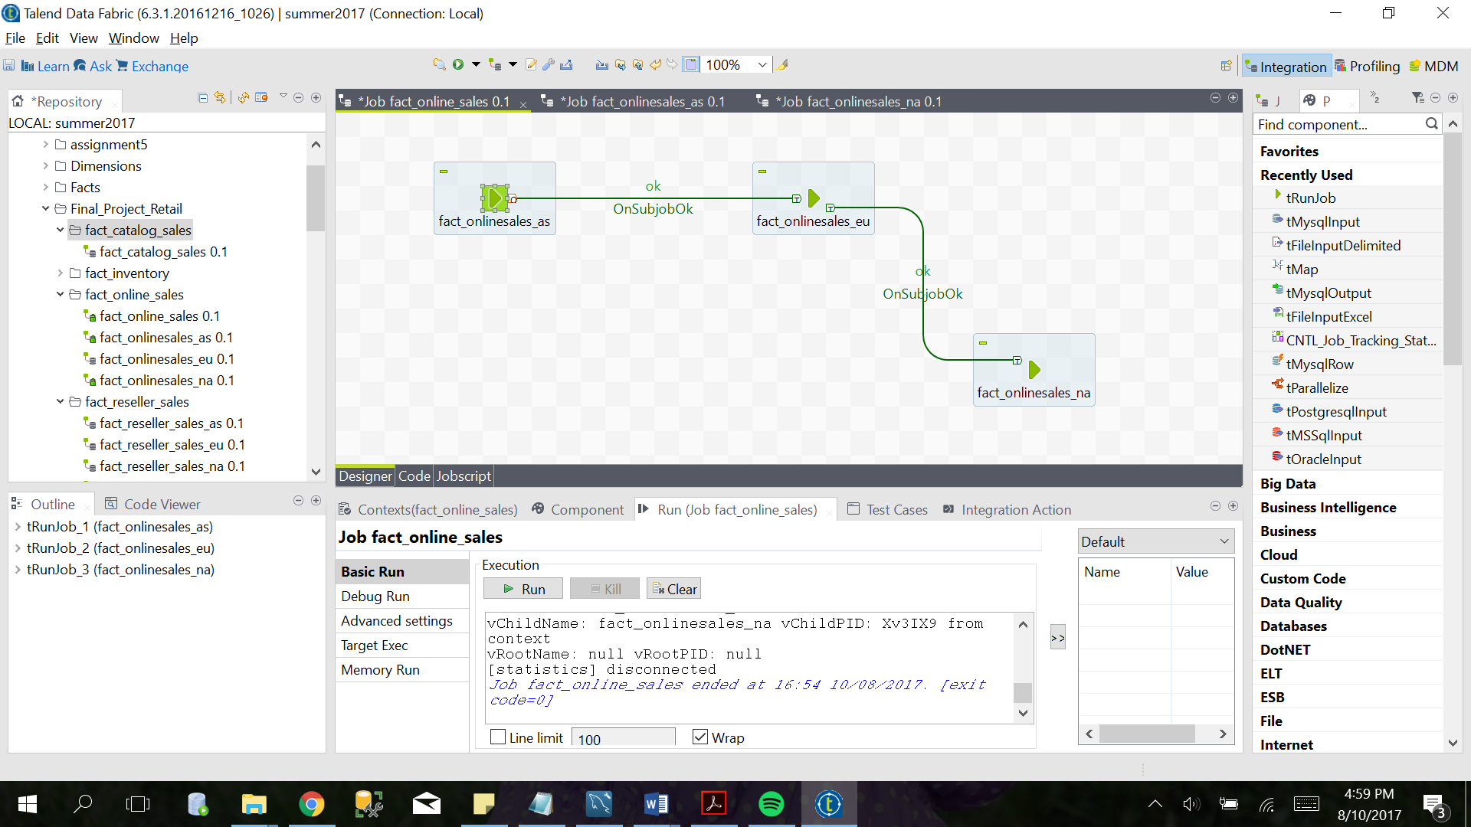

Figure 27: factOnlineSales

**Table Row Counts**

|  |  |  |  |  |  |  |  |  |  |  |  |  |  |  |  |  |  |  |  |  |  |  |  |  |  |  |  |  |  |  |  |  |  |  |  |  |  |  |  |  |  |  |  |  |  |  |  |  |  |  |  |  |  |  |  |  |  |  |  |  |  |  |  |  |  |  |  |  |  |  |  |  |  |  |  |  |  |  |  |  |  |  |  |  |  |  |  |  |  |  |  |  |  |  |  |  |  |  |  |  |  |  |  |  |  |  |  |  |  |  |  |  |  |  |  |  |  |  |  |  |  |  |  |  |  |  |  |  |  |  |  |  |  |  |  |
| --- | --- | --- | --- | --- | --- | --- | --- | --- | --- | --- | --- | --- | --- | --- | --- | --- | --- | --- | --- | --- | --- | --- | --- | --- | --- | --- | --- | --- | --- | --- | --- | --- | --- | --- | --- | --- | --- | --- | --- | --- | --- | --- | --- | --- | --- | --- | --- | --- | --- | --- | --- | --- | --- | --- | --- | --- | --- | --- | --- | --- | --- | --- | --- | --- | --- | --- | --- | --- | --- | --- | --- | --- | --- | --- | --- | --- | --- | --- | --- | --- | --- | --- | --- | --- | --- | --- | --- | --- | --- | --- | --- | --- | --- | --- | --- | --- | --- | --- | --- | --- | --- | --- | --- | --- | --- | --- | --- | --- | --- | --- | --- | --- | --- | --- | --- | --- | --- | --- | --- | --- | --- | --- | --- | --- | --- | --- | --- | --- | --- | --- | --- | --- | --- | --- | --- |
| |  | | --- | | table_schema | | retail_dw | | retail_dw | | retail_dw | | retail_dw | | retail_dw | | retail_dw | | retail_dw | | retail_dw | | retail_dw | | retail_dw | | retail_dw | | retail_dw | | retail_dw | | retail_dw | | retail_dw | | retail_dw | | retail_dw | | retail_dw | | retail_dw | | retail_dw | | retail_dw | | retail_dw | | retail_dw | | retail_dw | | retail_dw | | retail_dw | | retail_dw | | retail_dw | | retail_dw | | retail_dw | | retail_dw | | retail_dw | | |  | | --- | | table_name | | customer_stage | | dim_reject_codes | | dim_sor | | dim_sor_system | | dimaccount | | dimchannel | | dimcurrency | | dimcustomer_company | | dimcustomer_person | | dimdate | | dimentity | | dimgeography | | dimproduct | | dimproductcategory | | dimproductcost | | dimproductprice | | dimpromotion | | dimsalesterritory | | dimscenario | | dimstore | | factexchangerate | | factinventory | | factinventory_rejects | | factonlinesales | | factonlinesales_rejects | | factsales | | factsales_rejects | | factsalesquota | | factsalesquota_rejects | | factstrategyplan | | factstrategyplan_rejects | | stage_factexchangerate | | |  | | --- | | table_rows | | 18645 | | 10 | | 91 | | 5 | | 24 | | 4 | | 28 | | 385 | | 16808 | | 44965 | | 306 | | 517 | | 2448 | | 8 | | 24440 | | 23124 | | 28 | | 265 | | 3 | | 306 | | 2192 | | 8671171 | | 745786 | | 11275835 | | 3280813 | | 14402934 | | 4132411 | | 5655641 | | 663089 | | 2766166 | | 248841 | | 2192 | | |  | | --- | | auto_increment | | 18870 | | 11 | | NULL | | NULL | | 25 | | 5 | | 29 | | 386 | | 17433 | | NULL | | 307 | | 518 | | 2518 | | NULL | | 27058 | | 24050 | | 29 | | 266 | | 4 | | 307 | | 2193 | | 8932554 | | 754515 | | 11400590 | | 3387500 | | 14539502 | | 4291048 | | 5833595 | | 669026 | | 2782885 | | 250686 | | NULL | |

**Total time to load Retail DW using Talend: 40 mins**